Asia-China-Shang-Bronze-Tiger eating man-Final-Final

Bronze Age, Shang bronze wine vessel, yu虎食人, LENGTH: 22.5CM/8.86Inches, HEIGHT: 34CM/13.39Inches' CONDITION: Rust on the body, museum quality.

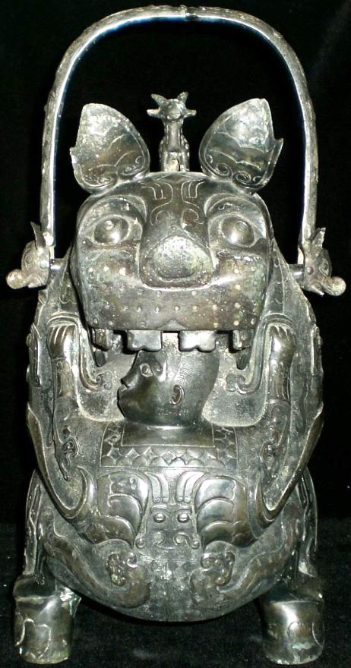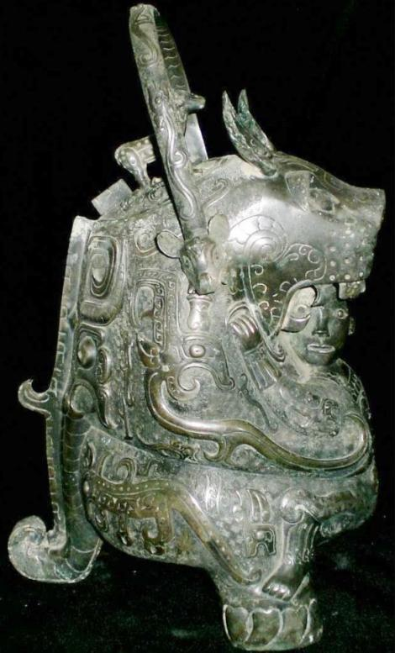

This erect standing composite bronze tiger is supported by its two rear feet and its tail. A human figure with his head in its gaping jaws and with his arms grasping its breast with his feet on its front feet is being held in place by the tiger with its front paws.

The tiger is clearly a composite of many animals. An antelope stands on its head:

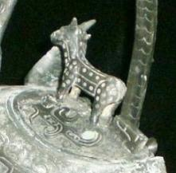

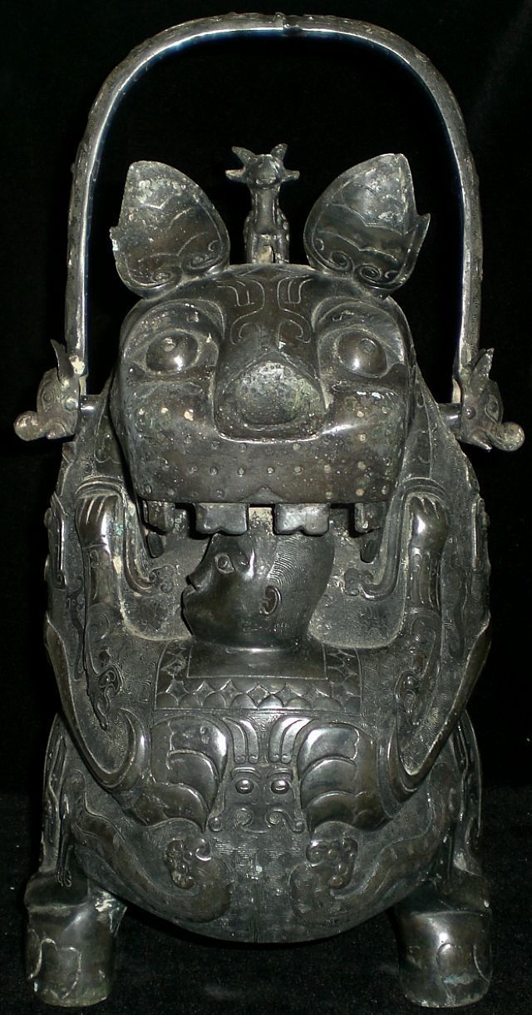

The human and the tiger are in the midst of a mutually tight embrace. The human is a male with closely cropped hair and, although barefoot, is wearing a tunic with a diamond-patterned border around the neck and with a two-horned dragon design on its back. Thus outfitted the human appears to be of high social status.

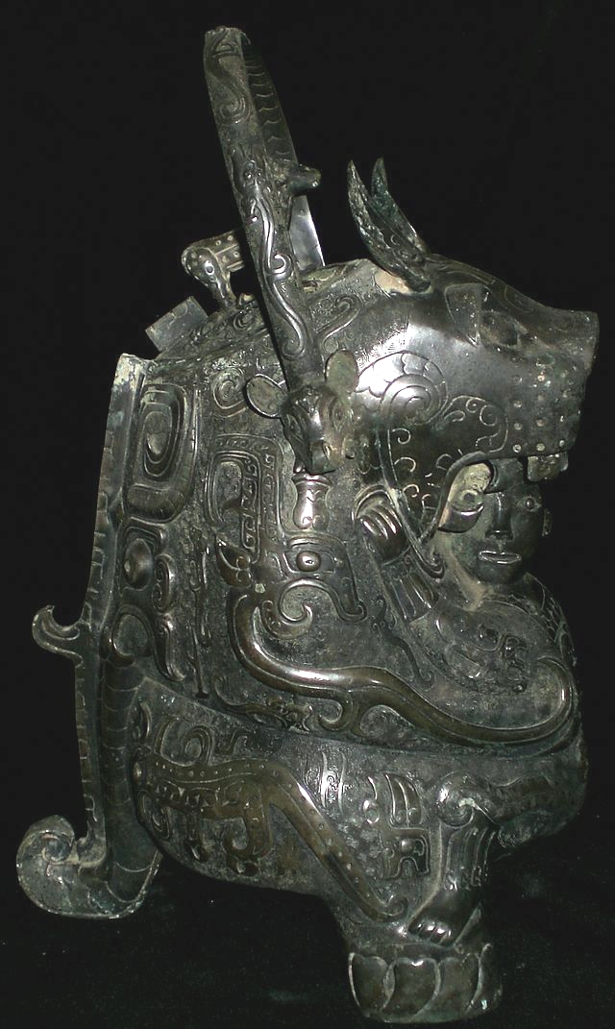

On either side of the tiger a dragon with an elaborate headdress encircles its breast as the human peers with wide-open eyes through the tiger's gaping jaws while an antelope-eared serpent with protruding wild boar tusks descends from the movable handle:

About the human's lower arms are gauntlets, much like those that protect an archer, and these are repeated around his ankles as serpent's tails encircle his feet. He is wearing no shoes on his four-toed feet.

Of course, all these fantastic beings interacting with the human are metaphors for numinous powers, and primary to the images is the tiger with its gaping mouth.

Except for Shang period oracle bone scripts we have no Shang period texts to interpret the concepts that are embodied in this intricate Shang period bronze casting. One of the texts which is much later but which does deal with fantastic creatures and landscapes is the *Shan Hai Jing* (山海, wg ***Shan-hai Ching*, "Mountains and Seas"**) a compilation of early 4th century BCE fantastic geography and myth. In it we find a depiction of a shaman-like individual, Pu Ting Hu Yü, who is said to have contact with the numinous world of spirit powers.

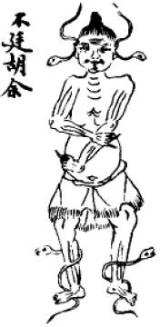

Pu Ting Hu Yü after Chang 1986: 71, fig. 28.

In this depiction we see two serpents encircling his barefoot legs. Two other serpents encircle his ears. This scene, while it is 1500 years too late for our purposes, does highlight two aspects of shamanic trance in China: the use of serpents which are associated with darkness and rebirth and the near nakedness of the participant suggesting his ascetic qualities and his non-priestly role in society. These qualities suggest that the shamanism as portrayed in the earlier Shang period bronze tiger-man yu vessel is actually depicting a later, priestly stage in the evolution of Chinese shamanism, since the figure wears an elaborately decorated tunic and arm and leg bands suggesting his elevated social rank.

The metaphor of the placing of one's head into the mouth of an animal or placing oneself into a cave is related to the shamanic experience: it is a metaphor for entering another realm of being and as such is an archetypal image in the collective unconscious of *Homo sapiens.*

**Many world cultures have developed this image as crossing the threshold into the unknown.**

Among the Paleolithic peoples of western Eurasia where dark caves were a realm of contact with numinous animal spirits through images painted on their walls and ceilings by Paleolithic shamans.

In Meso-America the dark cave is especially potent as the realm of spirit beings and also the habitations of serpents who are spirits close to water and who shed their skins in their own life-renewal events. 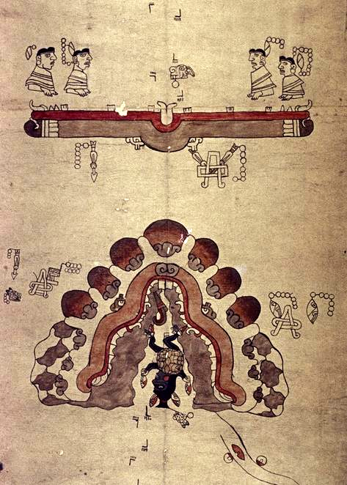

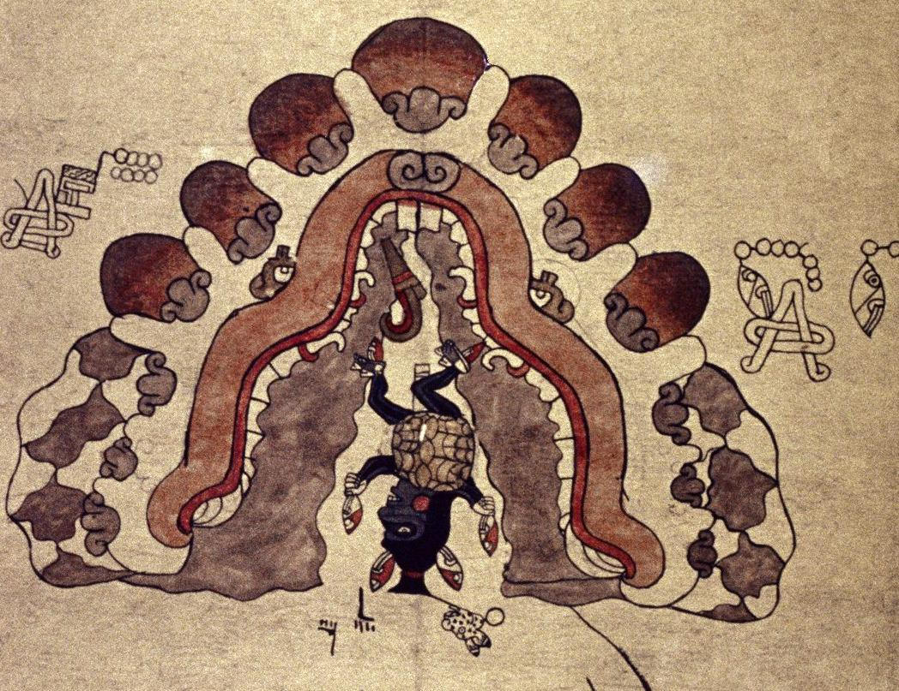

MS. Arch. Selden. A. 72, Bodleian Library, University of Oxford; 'The Selden Roll': a painted 16th century paper (*amatl*) roll from the Coixtlahuaca region incorporating both Mixtec and Aztec elements, apparently recording myths of origin and the migratory journey of the four divine ancestors up to the time when early settlement begins. After http://bodley30.bodley.ox.ac.uk:8180/luna/servlet/detail/ODLodl~1~1~30557~105646:The--Selden-Roll--?qvq=w4s:/what/MS.%20Arch.%20Selden.%20A.%2072%20%283%29;lc:ODLodl~29~29,ODLodl~7~7,ODLodl~6~6,ODLodl~14~14,ODLodl~8~8,ODLodl~23~23,ODLodl~1~1,ODLodl~24~24&mi=5&trs=7.

The importance of the Cave

Caves in Pre-Columbian Mesoamerica were places of initiatory rites related to life events such as entrance into adulthood and investiture with certain responsibilities. However, before these societal rites came the earlier events of shamanic quest and exorcism. And even before these events were those of a mythic time when the gods were born within caves and the first people issued forth from them and so caves were often depicted as the womb of mother earth.

In the later stages of the mythic use of caves, when shamanism as a local event of individuals for individuals was being eclipsed, four legendary Mixtec chiefs in search of power so that they might engender and then rule the Mixtec people found their way to the sacred cave of "the woman clothed in serpents", the goddess Xochiquetzal. The cave was formed by the two intertwined serpents of day and night. The serpents were metaphors both of the numinous darkness out of which power to rule emanated and also of the power of engendering new life from which will issue the Mixtec people. The four mythic Mixtec chiefs having made contact with Xochiquetzal, acquired the power to rule by being given the mysterious medicine bundle of Quetzalcoatl, the rain god. Henceforth, they are his functionaries; they have found how to sacrifice to the gods Xochiquetzal and Quetzalcoatl, and they have enthroned Quetzalcoatl on the Hill of Xochiquetzal and made New Fire there ushering in a new age, and they have renewed their covenant with their old tribal god Ce Ocelotl to make peace with the past, and all of this was accomplished in the darkness of Xochiquetzal 's cave.

Landscape in shamanism is important, and in the Yucatan peninsula which is predominantly a limestone shelf caves are everywhere. They are part of the local landscape For instance, Xochiquetzal 's cave was depicted as having stalactites that hung down like metaphoric teeth in the maw of a metaphoric cave monster. Indeed, the connection of the cave with the maw of a mythic beast like a numinous jaguar is suggested elsewhere more explicitly.

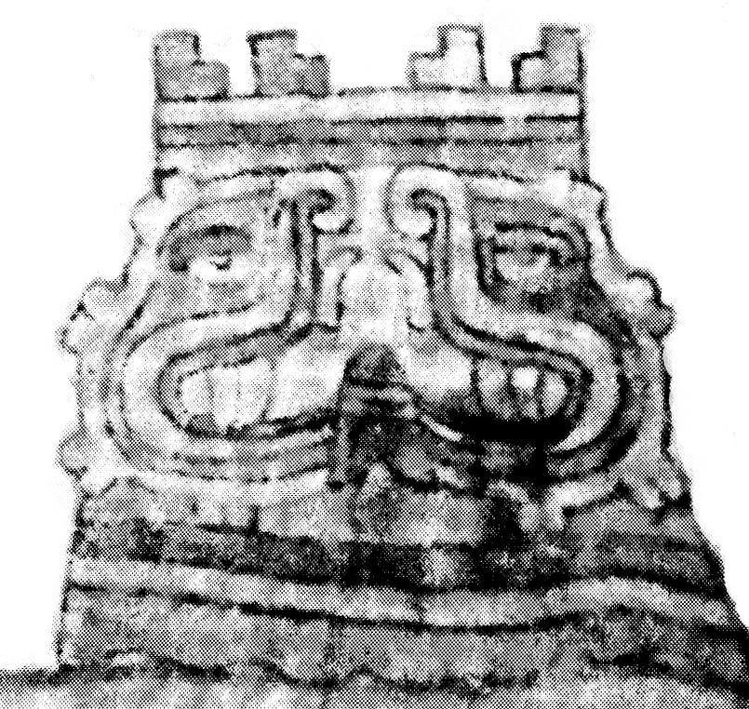

Depiction of the crenellated earth-monster cavern in the Coixtlahuaca Basin that marks the threshold between those who settled inside and outside the basin. Detail from the Codex Tequixtepec I from the Honorable Ayuntamiento San Miguel Tequixtepec, Oaxaca.

In addition the vapors emitted from caves considered sacred are akin to the vapors emitted from the maw of a sacred monster like the Shang tiger: they have special powers to induce visions as they are emitted from beyond the threshold of ordinary being--the numinous regions where special powers emanate.

To enter these regions of eternal darkness the Maya have an important glyph "enters the cave" (och-ch'een) incorporating logograms of the cave vapors

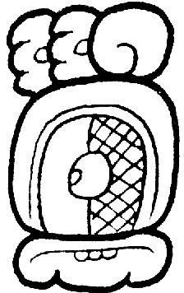 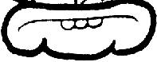 SHAPE \* MERGEFORMAT 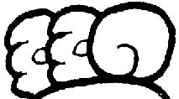

After David Stuart in Vogt and Stuart 2005, fig 7.7 a, p. 161.

Now these logograms also have a counterpart in Honshan China where there may be the beginnings of a form of logogram for the very same verb: "enters the cave" or more precisely "crosses the threshold of the cave's mouth":

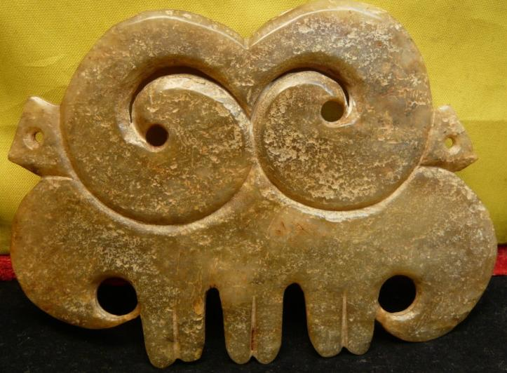

Hongshan Jade Cloud and Tooth Pendant, width 13.5 cm., height 10cm., thickness 0.6cm. Atlantika Collection.

This pendant we suggest is such a logogram, for it incorporates the motifs for vapors

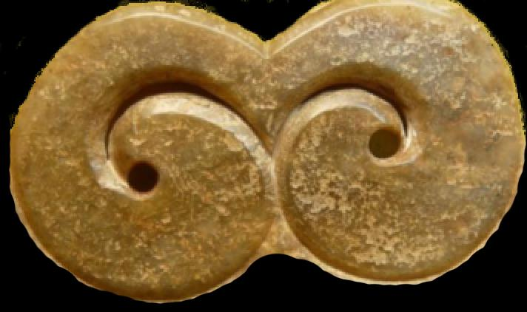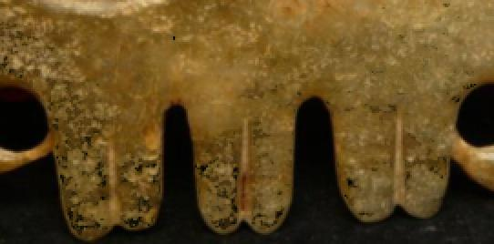

and the motifs for mouth of the numinous being in the form of teeth or in the case of caves, stalactites:

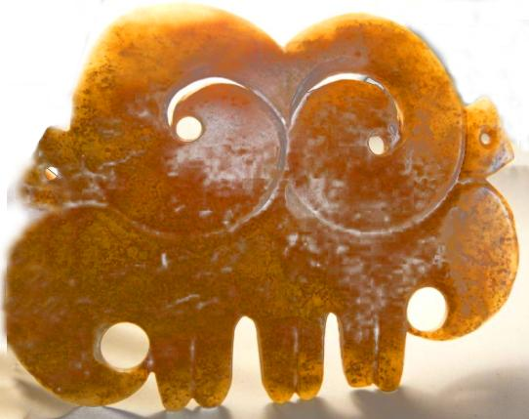

Hongshan Jade Cloud and Tooth Pendant, showing the cloud vapor pendant's luminosity when displayed against a light background which suggests its ethereal quality.

The similarity of this pendant with the Mayan glyph elements suggests a common conceptual idea relating to cloud like vapors and their imaging motifs. In addition the Hongshan pendant also has three double tooth-like appendages which may represent the mouth of the cave/tiger from which issues the vapors imaged above.

REFERENCES

Vogt, Evan Z and David Stuart. 2005. Chapter 7. Some notes on the ritual caves among the ancient and modern Maya. In James E. Brady and Keith M. Prufer, eds., In the maw of the earth monster: Mesoamerican ritual cave use (Austin: University of Texas Press.

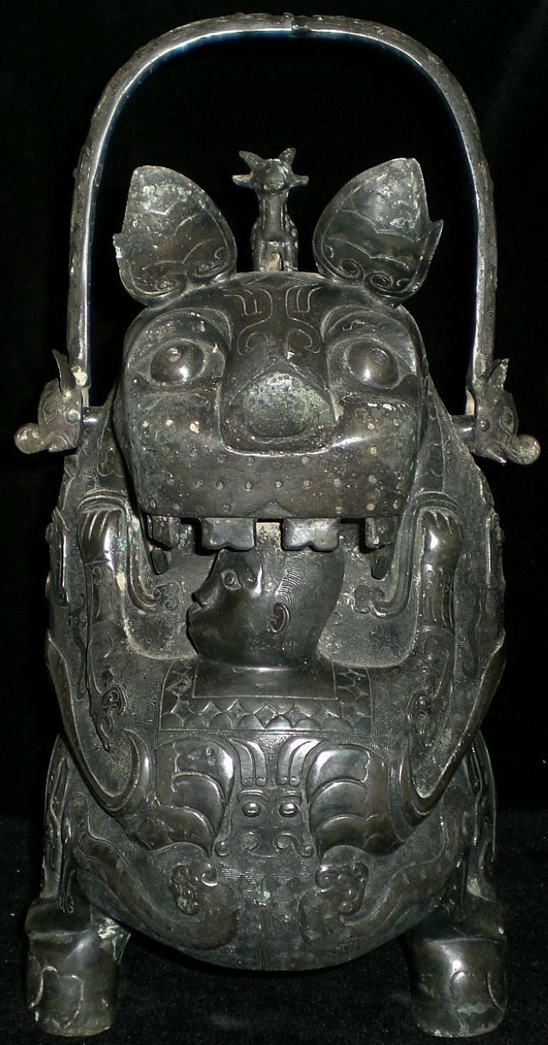

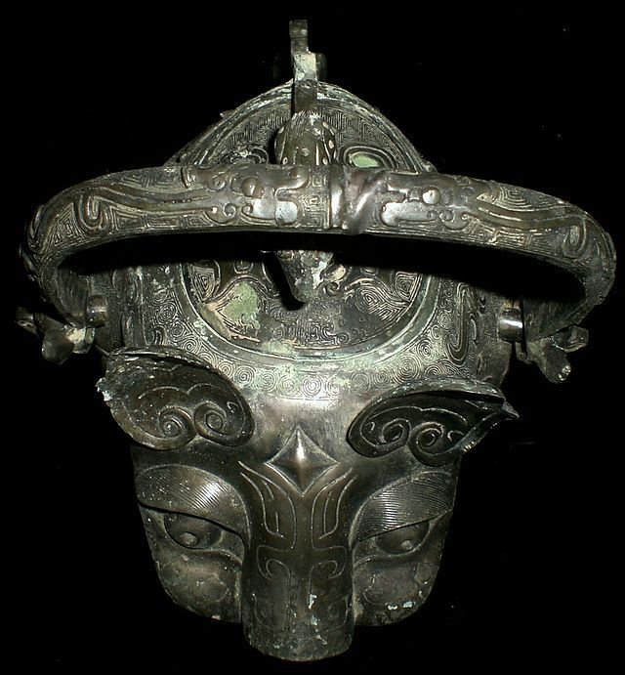 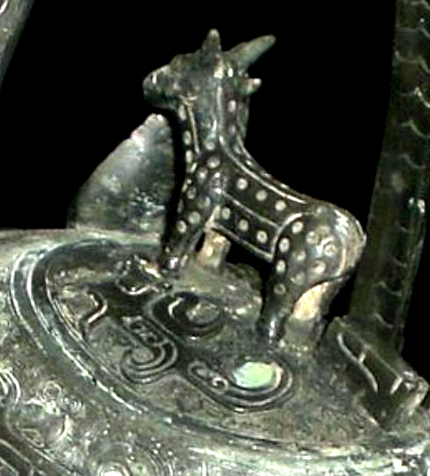  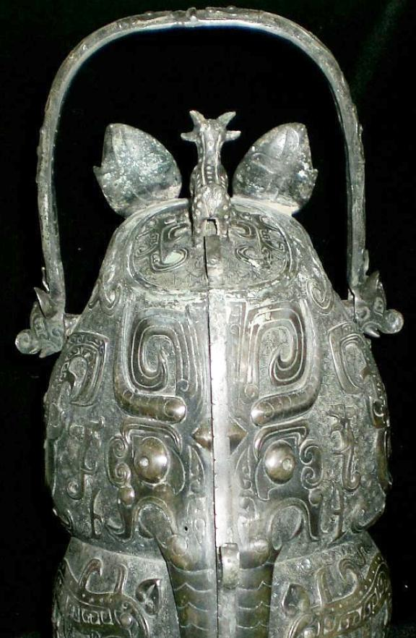 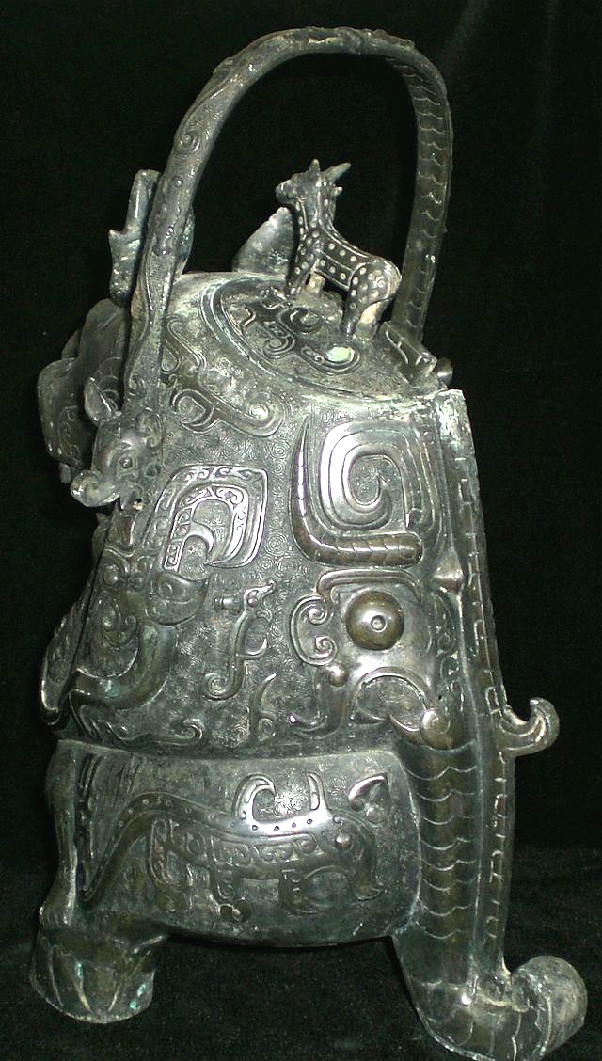

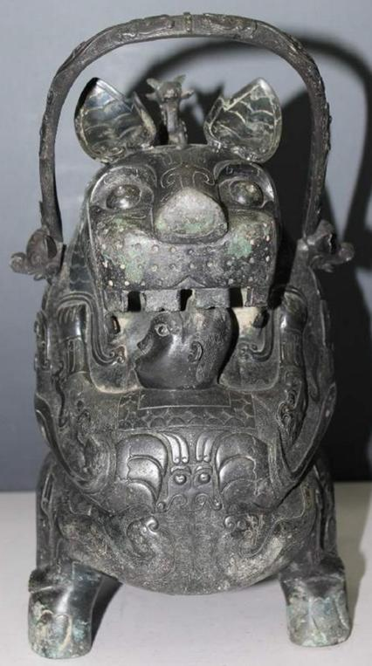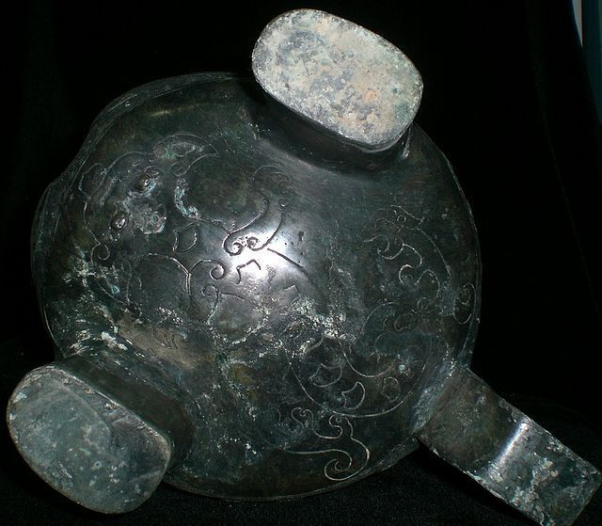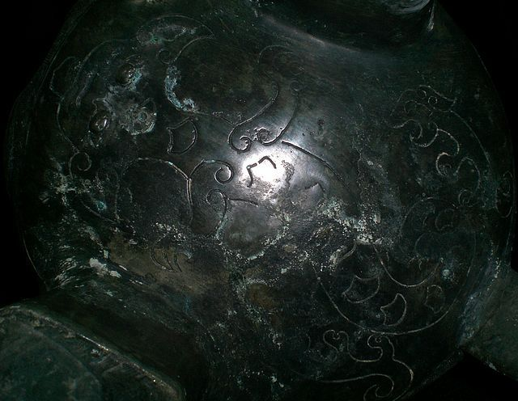

Bronze casters mark 

The tiger (hu 虎) is one of the twelve animals of the Chinese zodiac and is considered the ruler of the beasts on Earth as opposed to the dragon which rules the beasts in the sky and heavens.  
  
The tiger was perceived to be a symbol of protection: the word for tiger (hu) is also a pun because it has the same pronunciation as the word "protect" (hu 护). In ancient China, the tiger was the Guardian Spirit of Agriculture which could devour the Drought Demon.

The *you* bronze vessel called "Hushiren" ("Tiger Eats Man") is the bronze treasure of the Late Shang of China. There were two pieces found the first place, one is preserved in the museum of Japan while the other is in Paris Municipal Oriental Gallery of France. "Eating-man-tiger" reflects the myth of spirit-eating-tiger, that is, the ancients in primeval society used the brave and fierce tiger to drive away the evil spirits.   
  
Another name for this bronze vessel is *"ruhu"* - "milk-feeding tiger".   
  
It is shaped like a tigress holding a small human who is hugging a feline, while his head is placed under the mouth of the animal. The person's head is facing the tiger's wide open mouth, and it t seems that the tiger intends to eat the head of the man, but at the same time the person turns his head to one side and his face expression doesn't show any fear.   
  
The theme of a feline joined with a human figure, although present during the Shang Kingdom, is more common in the South China. It could be linked to a legend described in the Zuozhuang, an ancient commentary in the Spring and Autumn Annals (8th – 5th century B.C.) which tells the story of the grandson of Ruoao, born in the Chu Kingdom, named Ziwen who as a baby was rescued and raised by a tigress.   
  
The calm expression on the person’s face and the confident manner in which his feet rest on the feline’s paws give credit to this explanation. This legend is part of the totemic narratives that establish the origins of many aristocratic clans, bringing together man and beast in a protective relationship or through a sexual union that leads to the birth of a mythical ancestor of the Hu Kindom of the Shang Dynasty.   
  
The archaeological context behind the discovery of this piece is unknown. However, such designs were predominant features of Shang dynasty bronze art and artifacts. This artifact is complexly made which shows the excellent skill of casting art. Most of the surface patina on it. As the same as the majority of the bronze statues of late Shang, it has elaborate and complex decorations and takes the man and beast as the motif. The lower part of the *you* and the tiger's tow front paws and tail form three supporting points. There is an oval-square opening on the back of the tiger with a lid where a small dragon stands on. The prolific decoration on the dark green bronze, consisting of large animal motifs, stands out against a background of square spirals and kuilong, snakes and cloud and lightening patterns, is also characteristic of the Shang Era.   
  
What it expresses - tiger eats or feeds man - remains mystery, it's up to you to decide.  
  
Such bronze vessels served as a key instruments in aiding shamans in communicating between heaven and earth, or between ancestral spirits and other deities and living people. Symbolism and ritual status of "Tiger & Man" *you* vessel reflects the legendary powerful pantheon of ancient Chinese mythology and cosmology.

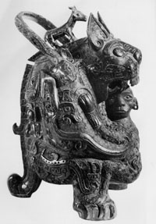

Ritual 'Yeou' vase known as 'The Tigress', detail, late Shang Dynasty, early 11th century BC (bronze) (see also 382541 and 170248)

Image ID: BCT 382542

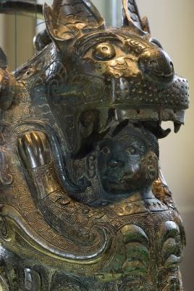

**Credit:** Ritual 'Yeou' vase known as 'The Tigress', detail, late Shang Dynasty, early 11th century BC (bronze) (see also 382541 and 170248), Chinese School, Shang Dynasty (1766-1050 BC) / Musee Cernuschi, Paris, France / Photo © Jacopo Brancati / The Bridgeman Art Library

|  |
| --- |
| BCT 382542  Image number: |
| Ritual 'Yeou' vase known as 'The Tigress', detail, late Shang Dynasty, early 11th century BC (bronze) (see also 382541 and 170248)  Title: |
| [Chinese School, Shang Dynasty (1766-1050 BC)](http://www.bridgemanart.com/search/artist/Chinese-School-Shang-Dynasty-1766-1050-BC/29483)  Primary creator: |
| Chinese  Nationality: |
| [Musee Cernuschi, Paris, France](http://www.bridgemanart.com/search/location/Musee-Cernuschi-Paris-France/3169) REFERENCESCh'en, Pang-huai (Banghuai). 1959. Jia gu wen ling shi : fu kao shi. ["Study of oracle bone inscriptions"]. Tianjin : Tianjin ren min chu ban she. 50 leaves. |

